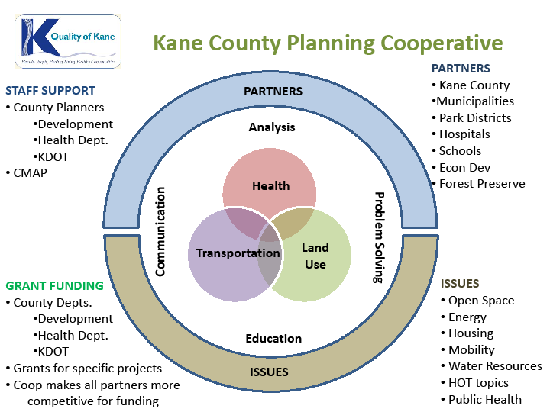
Kane County Planning Cooperative
2040 Plan Implementation Grants:
Creating Healthier Communities Grant
2012 Application Packet

Send Completed Application to:
Paper Applications: Kane County Planning Cooperative
719 Batavia Avenue, Geneva, IL 60134
Electronic Applications: KCPlanCoop@co.kane.il.us
Due Date: July 31st, 2012, 4:30 p.m.
Kane County Planning Cooperative
2040 Plan Implementation Grants:
Creating Healthier Communities Grant
2012 Application Guidelines
Purpose
The Kane County Planning Cooperative Creating Healthier Communities Grant is designed to provide funding to implement the Kane County 2040 Plan, focusing on 6 of the plan’s high priority health, land use and transportation policy recommendations. Widespread implementation of these 6 policies will have positive, measurable population health impact, decrease chronic disease burden and reduce health disparities in Kane County.
Grant Funding
The funding for the Creating Healthier Communities Grant was made possible through The Power of Policy: Innovation to Improve Health, a $40,000 award given to Kane County Health Department. The award was sponsored by the American Public Health Association (APHA) and funded by the Centers for Disease Control and Prevention’s National Public Health Improvement Initiative. Kane County is one of only six health departments that were selected out of a pool of 121 applicants. The award and grant was given to Kane County in recognition of the potential for the new Kane County Planning Cooperative to help the County reach its goal to make Kane County’s residents the healthiest in Illinois.
Kane County Planning Cooperative
The formation of a Kane County Planning Cooperative is the central core of the 2040 Implementation Strategy. The main mission of the Cooperative will be to encourage education and information sharing related to planning and to assist with local planning decisions. The Cooperative will be staffed primarily with County planners from three departments – Development, Health and Division of Transportation (KDOT) – in addition to support from CMAP. The primary goal is to fill the gaps for addressing current critical topics common to many of Kane County’s municipal and other partners by providing a local forum for education, analysis, communication, problem solving and by integrating health, transportation, and land use planning.
The Kane County Planning Cooperative is a resource for municipalities and other local planning efforts by providing a forum for information and discussion on critical planning issues and emerging trends. Participation is open to municipal staff, elected and appointed officials, and other decision-makers.
Eligible Applicants
Funding is available to municipalities in Kane County as well as other public and civic organizations, including, but not limited to, park districts, school districts, hospitals, schools, and economic development organizations. Funding will not be made available to individuals.
Project Eligibility
The Kane County Planning Cooperative Creating Healthier Communities Grant will provide funding support to initiatives that implement one or more of the Kane County 2040 Plan’s six high priority health, land use and transportation policy recommendations. Contracts will be entered with organizations for projects ranging between $1,000.00 and $5,000.00. All applicants are required to provide a partial match of fifty cents per dollar awarded in either in-kind or cash contributions. The portion of the project that is being funded by the grant will be required to be completed by December 31st, 2012. All selected applicants must agree to participate in program evaluation activities of the APHA Power of Policy: Innovation to Improve Health grant conducted by Kane County and/or Northern Illinois University. This will include the completion of a final report detailing project activities on or before December 31st, 2012. More information on reporting activities will be given to selected applicants.
Eligible projects will address one or more of the following six Kane County 2040 Plan high priority policies:
- Developing municipal bike- and walk-ability plans
- Establishing / expanding community gardens
- Expanding smoke-free campuses
- Expanding safe routes to school plans to all nine school districts
- Achieving USDA Healthier US School Challenge standards in all nine school districts
- Instituting comprehensive, evidence-based workplace wellness policies
Eligible projects will fall into one of the following four categories:
- Pre-Planning: This could include projects that focus on public outreach, educating the public, and gathering data necessary to begin the planning process. Examples:
  - Walk-ability or access audits around proposed parks, community gardens, or farmer’s markets to identity barriers that may need to be addressed.
  - Public outreach events / workshops to inform the public of upcoming planning activities
- Plan Development: This could include developing a plan for an area or feature. Examples:
  - Hiring a consultant to begin work on a bike- or walk-ability plan
  - Working with a local school or school district to create a safe routes to school plan for that area
- Plan Publishing: This could include publishing a completed plan, creating social media (web site, app, etc.) for a completed plan or disseminating information to inform the public of efforts to achieve one of the six high priority policies. Examples:
  - The purchase of paper/printing materials to disseminate information regarding safe routes to school plans; comprehensive, evidenced-based workplace wellness policies; or municipal bike- and walk-ability plans
  - The procurement of a consultant to create a social media campaign to promote the efforts made in regards to one of the six high priority recommendations
- Plan Implementation: This could include projects that focus on actually realizing aspects of completed safe routes to school plan; comprehensive, evidenced-based workplace wellness policy; or municipal bike- and walk-ability plan. Examples:
  - Engineering/plans for a physical improvement (sidewalk, park, etc.)
  - Outreach workshops / citizens meetings to inform the public of a completed plan
Allowable Budget Items
Allowable costs relate only to policy development and cannot be related to hard expenditures (e.g. the purchasing of fertilizer or gardening materials or the purchasing of cement mix). The following are the allowable costs for the Creating Healthier Communities Grant:
- The procurement of a private consultant
- Purchasing materials to disseminate information
- Staff time for the project (may be both funded and used as in-kind match)
- Training to help with the implementation
- Travel costs related to trainings or technical assistance
- Small incentives to attend trainings
Review Process
Members of the staff will evaluate eligible projects with the Kane County Regional Planning Commission and Development Committee. Here are the criteria that eligible projects will be evaluated on:
- Implementation of one or more of the Kane County 2040 Plan’s six high priority health, land use and transportation policy recommendations. This is a requirement for all projects. Priority will be given to projects that incorporate more than one of the six high priority policy recommendations.
- Priority will be given to projects that incorporate other aspects of the Kane County 2040 Plan as well.
- Priority will be given to projects that create long-term benefits
- Project readiness. Since approved projects must be completed by December 31st, 2012, priority will be given to projects that are ready to proceed or face the fewest obstacles that could prevent their timely completion.
Selected projects will be announced in late August. All applicants will be notified via letter or email as to whether or not their project was selected. Those projects that are selected will be given further instructions as to how to proceed with the grant process.
How to Apply
Applicants should submit the attached “Kane County Planning Cooperative Creating Healthier Communities Grant 2012 Application” form by mail or email by the following deadline: 4:30 p.m. on July 31st, 2012. Submittal by email is strongly encouraged.
Mail: Kane County Planning Cooperative
Attn: Sean Glowacz
719 Batavia Avenue, Building A
Geneva, IL 60134
Email: KCPlanCoop@co.kane.il.us
For Further Assistance
For more information regarding application procedures and project eligibility, please contact Sean Glowacz at glowaczsean@co.kane.il.us or (630) 232-3491. For more information on Kane County planning initiatives please visit www.qualityofkane.org.

Kane County Planning Cooperative
2040 Plan Implementation Grants:
Creating Healthier Communities Grant
2012 Application

1) APPLICANT INFORMATION
Organization: __________
Address: __________
City, State, Zip: __________
Contact Name and Title: __________
Phone: __________
Email: __________

2) PROJECT INFORMATION
Project Name: __________
Project Location: __________
Project Summary: (Description of the project purpose: Please limit your response to 500 words or less; Provide any additional information that will help explain project as attachments to your application or as links to online documents)
__________
Select the category that your project falls under. Please describe how your project relates to the selected category.
Choose an item.
__________
Select the Kane County 2040 Plan High Priority Health, Land Use and Transportation Policy Recommendation(s) that your project pertains to. Please describe how your project relates to that policy recommendation. Extra drop down boxes are included in case your project relates to more than one policy recommendation.
Choose an item.
__________
Choose an item.
__________
Choose an item.
__________

3) PROJECT FUNDING
1) Total Project Cost: __________
2) Total Funds Requested: __________
3a) Total Matching Funds: __________
3b) Total In-Kind Services: __________
Attach a budget for your project. Indicate which items you are requesting grant funding for – check the grant application packet to ensure that these items are covered under the grant guidelines.

4) PROJECT TIMELINE
1) Anticipated Project Start Date: __________
2) Anticipated Project End Date: __________
3a) Do you plan on using a consultant? Choose an item.
3b) If so, is the consultant already on retainer? Choose an item.
Attach a timeline for your project. Include target completion dates for critical steps.

5) WHERE DID YOU HEAR ABOUT THIS GRANT?
Directly from Kane County Staff
Kane County Planning Cooperative Newsletter
Other Electronic Newsletter
Email Announcement
Kane County Website
Other (Please List) __________

6) PROGRAM EVALUATION AGREEMENT
By applying for this grant, my organization agrees to participate in program evaluation activities of the APHA Power of Policy: Innovation to Improve Health grant conducted by Kane County and/or Northern Illinois University.

